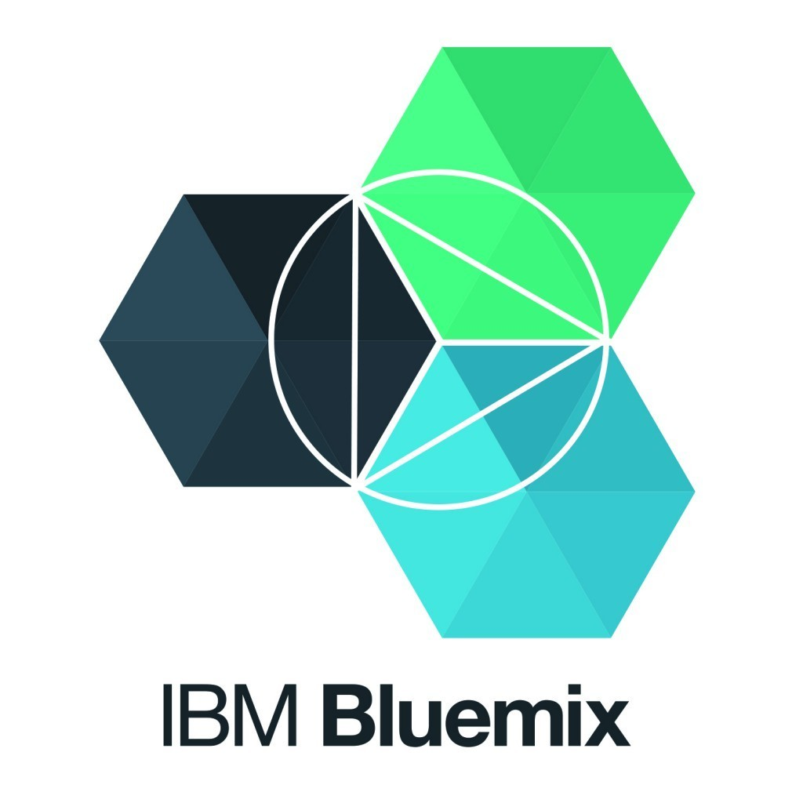
IoT Healthcare Simulator Powered by IBM Watson.

Step 1

Create IoT starter boiler plate app:
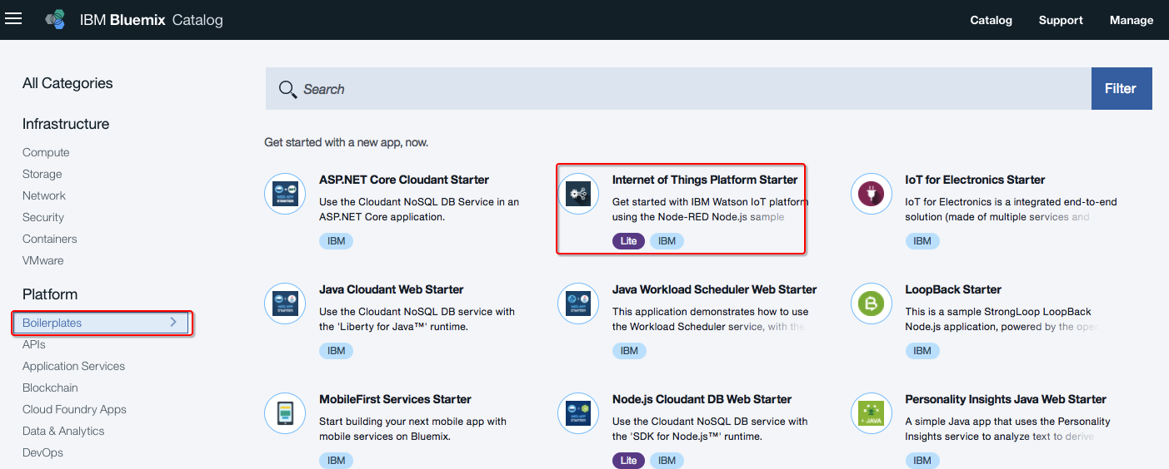

Step 2

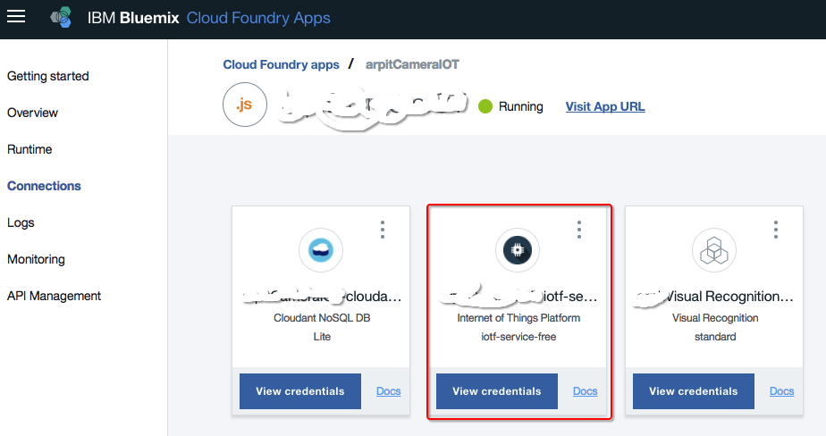
Register IoT devic
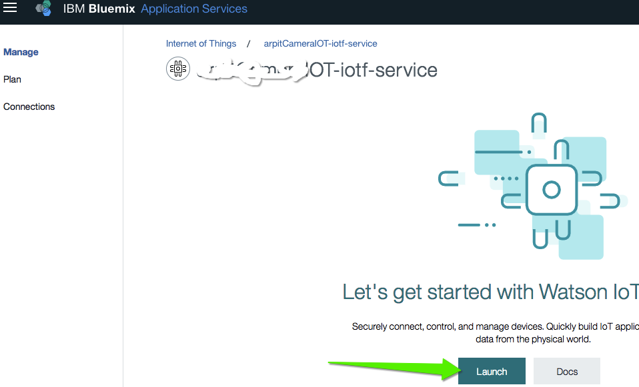
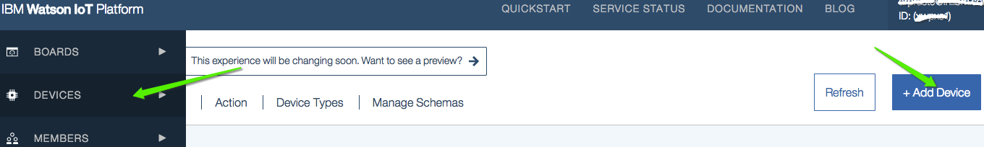
Step 3

Get below parameters after registering device:

- Organization ID
- Device Type
- Device ID
- Authentication Method
- Authentication Token

Step 4

Simulate IoT device in Node Red:

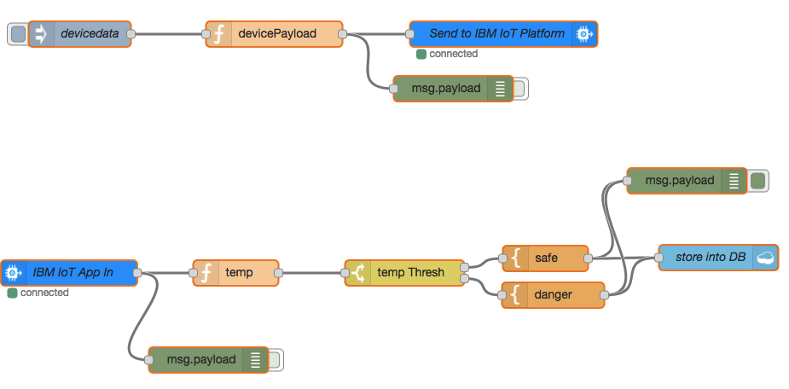

Take json from (https://github.com/arprasto/LabDemo/blob/master/IotSimulatorWithoutAndroid.json)

